**DAILY ONLINE ACTIVITIES SUMMARY**

|  |  |  |  |  |  |  |  |  |
| --- | --- | --- | --- | --- | --- | --- | --- | --- |
| **Date:** | **21/05/2020** | | | | | **Name:** | **Sheetal** | |
| **Sem & Sec** | **8B** | | | | | **USN:** | **4AL16CS091** | |
| **Online Test Summary** | | | | | | | | |
| **Subject** | | **SMS** | | | | | | |
| **Max. Marks** | | **60** | | **Score** | | | **45** | |
| **Certification Course Summary(Internship)** | | | | | | | | |
| **Task** | **Study-Learning data analytics concepts with platform specified**  **POC-working development of dashboard on customer churn analysis with sales dataset provided in BI tool** | | | | | | | |
| **company** | | | **Gain-insights** | | **Duration** | | | **9 hr** |
| **Coding Challenges** | | | | | | | | |
| **Problem Statement:**  **1)** C Program to Reverse a Linked List in groups of given size. | | | | | | | | |
| **Status:completed** | | | | | | | | |
| **Uploaded the report in Github** | | | | | **Yes** | | | |
| **If yes Repository name** | | | | | [alvas-education-foundation](https://github.com/alvas-education-foundation)/ **[sheetal-shettigar](https://github.com/alvas-education-foundation/sheetal-shettigar)** | | | |
| **Uploaded the report in slack** | | | | | **Yes** | | | |

ONLINE TEST:

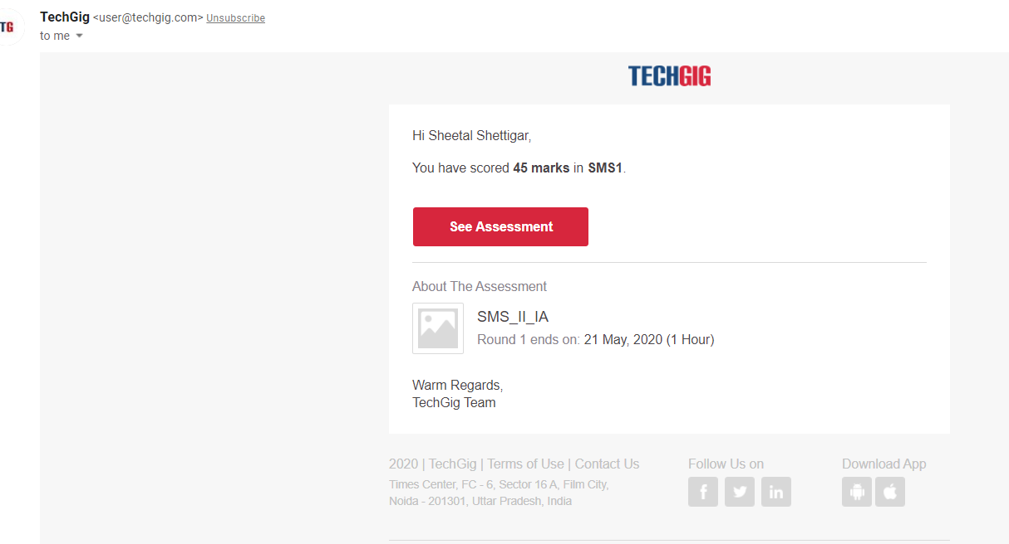

CODING CHALLENGE:

PROGRAM 1 :  
#include<stdio.h>

#include<stdlib.h>

struct Node

{

int data;

struct Node* next;

};

struct Node reverse(struct Node head,int k)

{

struct Node current= head;

struct Node next= Null;

struct Node prev= Null; ko

int count = 0;

while(current!=Null && count<k)

{

next= current->next;

current->next = prev;

prev= current;

current= next;

count++;

}

if ( next!=Null)

head->next= reverse( next,k);

return prev;

}

void push( struct Node ==head_ref,int new_data)

{

struct Node= new_node= (struct Node*) malloc(sizeof(struct Node));

}

}

int main()

{

Struct node *prev,*head,*p;

int n,i;

printf ("number of elements:");

scanf("%d",&n);

head=NULL;

for(i=0;i<n;i++)

{

p=malloc(sizeof(struct node));

scanf("%d",&p->data);

p->next=NULL;

if(head==NULL)

head=p;

else

prev->next=p;

prev=p;

}

return 0;

}